**Warranty Claim Report**

**Return address: Huf Baolong Electronics Bretten GmbH Warranty Department, Ratinger Strasse 10, 42579 Heiligenhaus**

**Germany**

**Product details** (to be completed by customer)

|  |  |  |  |
| --- | --- | --- | --- |
| Huf Description |  | | |
| Huf Article Number |  | Quantity |  |
| Huf Serial Number |  | Production Date |  |
| Customer- / Invoice Number |  | Invoice Date |  |
| **Customer Details** (to be completed by customer) | | | |
| Customer |  | | |
| Customer Claim Number |  | | |
| Vehicle Type, Model, Year |  | | |
| VIN Number |  | | |
| KM – Performance |  | | |
| Error Description  Please send us an invoice copy of your customer |  | | |

(to be completed by Huf Baolong Electronics Bretten)

|  |  |  |  |
| --- | --- | --- | --- |
| IAM-Number |  | Receipt IAM |  |
| Sent to |  | Date for Analysis |  |

|  |  |
| --- | --- |
| **Nr.** | **Markierungen** |
| 1 | Huf Description |
| 2 | Huf Serial Number |
| 3 | Date Of Production /Frequency |

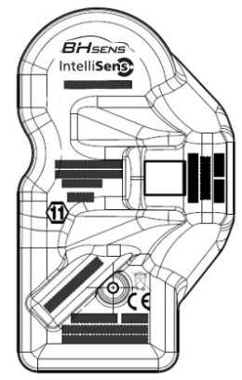 ­­

1

2

3

**00.0425 Warranty Report EU**